**DATABASE STRUCTURE DIAGRAM:**

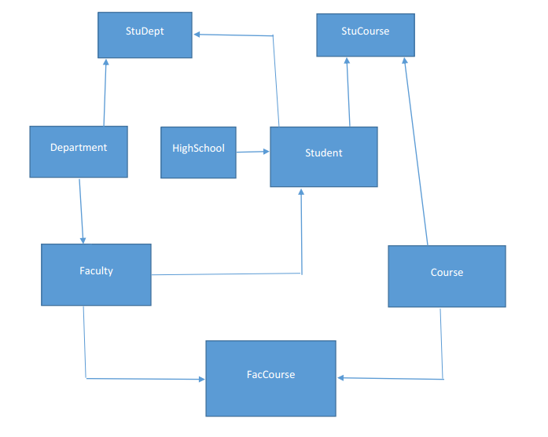

**ER - DIAGRAM:**

